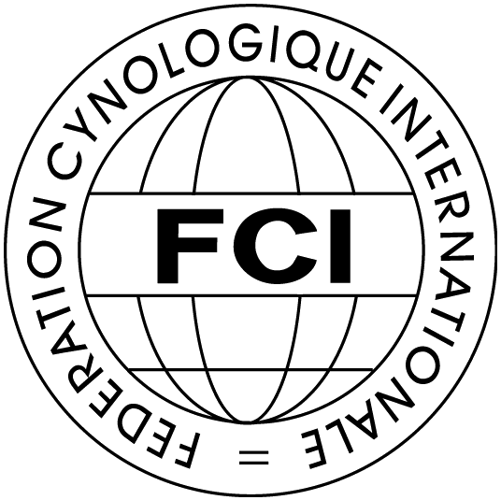 | Federation Cynologique Internationale (FCI)  Kennel Union of Moldova (UChM)  16 of December - 18 of December , 2016  Chisinau, Moldova | 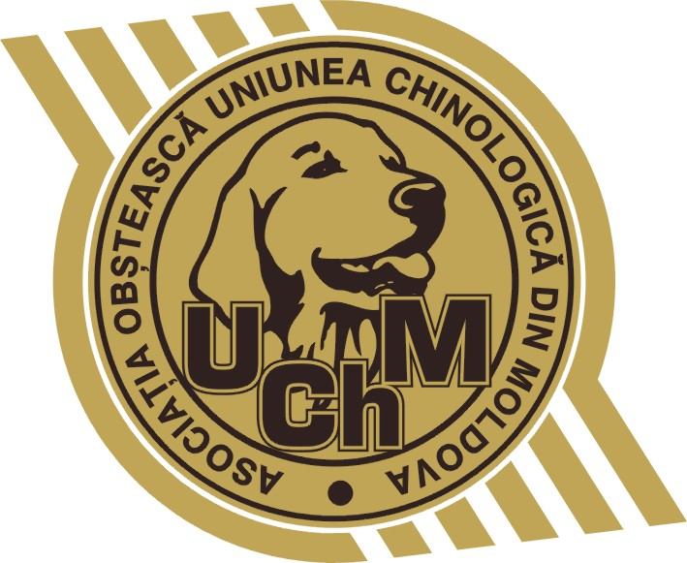

Class | 16-12-2016  CACIB-FCI | 17-12-2016  CACIB-FCI | 18-12-2016  CACIB-FCI | 17&18—12-2016  2xCAC-Moldova
BABY (3 - 6 months)
PUPPY (6-9 months)
JUNIOR (9-18 months)
INTERMEDIA (15-24 months)
OPEN (since 15 months)
WORKING (since 15 months)
CHAMPION (since 15 months)
VETERAN (since 8 years)

Breed |  |  |  |  |  |  |  |  |  |  |  | Male
Color |  |  |  |  |  |  |  |  |  |  |  | Female
Dog’s nickname
Pedigree No |  |  |  |  |  |  |  |  |  | Date of birth
Titles or tests
Sire: name, pedigree No.
Dam: name, pedigree No.
Breeder
Owner
Address (street, zip, city, country)
Phone |  |  |  |  |  |  | e-mail
Date

The X-copy of pedigree and receipt on payment
must be added to the entry form.
Please send this entry form to the: UChM2013@GMAIL.COM

