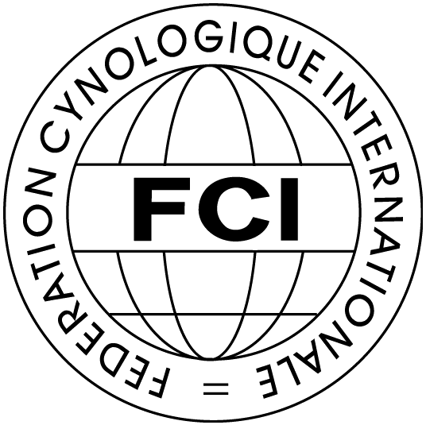 | Federation Cynologique Internationale (FCI)  Kennel Union of Moldova (UChM)  2-3 of May, 2015  Chisinau, Moldova | 

Class | 02-05-2015  CACIB-FCI | 03-05-2015  CACIB-FCI | 2-3—05-2015  2xCAC-Moldova
BABY (3 - 6 months)
PUPPY (6-9 months)
JUNIOR (9-18 months)
INTERMEDIA (15-24 months)
OPEN (since 15 months)
WORKING (since 15 months)
CHAMPION (since 15 months)
VETERAN (since 8 years)

Breed |  |  |  |  |  |  |  |  |  |  |  | Male
Color |  |  |  |  |  |  |  |  |  |  |  | Female
Dog’s nickname
Pedigree No |  |  |  |  |  |  |  |  |  | Date of birth
Titles or tests
Sire: name, pedigree No.
Dam: name, pedigree No.
Breeder
Owner
Address (street, zip, city, country)
Phone |  |  |  |  |  |  | e-mail
Date

Entry fee:
For foreign citizens
CACIB-FCI – 60-00 Euro
2xCAC-Moldova – 70-00 Euro
2xCACIB-FCI + 2xCAC-MD – 140-00 Euro
Class Baby, Puppy – 20-00 Euro
Veteran class – 20-00 Euro

For moldavian citizens
CACIB-FCI – 400-00 Lei RM
2xCAC-Moldova – 600-00 Lei RM
2xCACIB-FCI + 2xCAC-MD – 900-00 Lei RM
Class Baby, Puppy – 250-00 Lei RM
Veteran class – 250-00 Lei RM

The X-copy of pedigree and receipt on payment
must be added to the entry form.
Please send this entry form to the: UChM2013@GMAIL.COM

